

UNIVERSITY OF MUMBAI
CENTER FOR DISTANCE AND OPEN EDUCATION (CDOE)

CERTIFICATE

THE EXPERIMENTS DULY SIGNED IN THIS JOURNAL REPRESENT THE WORK DONE BY Ms. SANJANA SUSHANT RAUT APPLICATION ID: 20021 & SEAT NO.: 8221303 RESPECTIVELY IN SEMESTER I OF FIRST YEAR OF MASTER OF COMPUTER APPLICATION (NEP ) IN THE COMPUTER LABORATORY OF PCP CENTER D.T.T.S.COLLEGE MALAD (EAST) FOR SUBJECT WEB TECHNOLOGIES (IWT). During The Academic Year 2025-2026.

SUBJECT INCHARGE HEAD OF DEPARTMENT EXTERNAL EXAMINER

INDEX

Module No. | Sr. No. | Topic | Pg  No. | Sign
1. |  | Introduction to Node JS
 | 1A. | Install Node JS and verify Installation | 3
 | 1B. | Node.JS REPL Terminal | 4
2. |  | Node.js Modules, Events & Functions
 | 2A. | Node JS callback pattern function callback | 5
 | 2B | Event emitter pattern | 6
3. |  | File Handling & HTTP Web Server
 | 3A. | FS Module File Path | 7
 | 3B. | Read file in Node.JS | 8
4. |  | Databases
 | 4A. | Connect MySQL with Node.JS | 9
 | 4B | Insert Data in SQL using Node.JS | 10
5. |  | Angular JS Basics
 | 5A. | Setting Up the Environment | 13
 | 5B. | First Application (Multiplier) | 14
6. |  | Filters, Directive
 | 6A. | Experiment: program to display your name with welcome note: HELLO | 15
 | 6B | Experiment: Create an application using Filters | 16
7. |  | Controllers
 | 7A. | Programming Controllers & $scope object | 19
 | 7B. | Adding Behavior to a Scope Object | 20
8. |  | Forms and SPA (Single Page Application):
 | 8A. | Create Simple Angular Forms using different input controls & events | 21
 | 8B. | implement the concept of Single page application | 24

Practical No 1 : Introduction to Node JS
1A.
Aim : Install Node JS and verify Installation
- Download Node JS
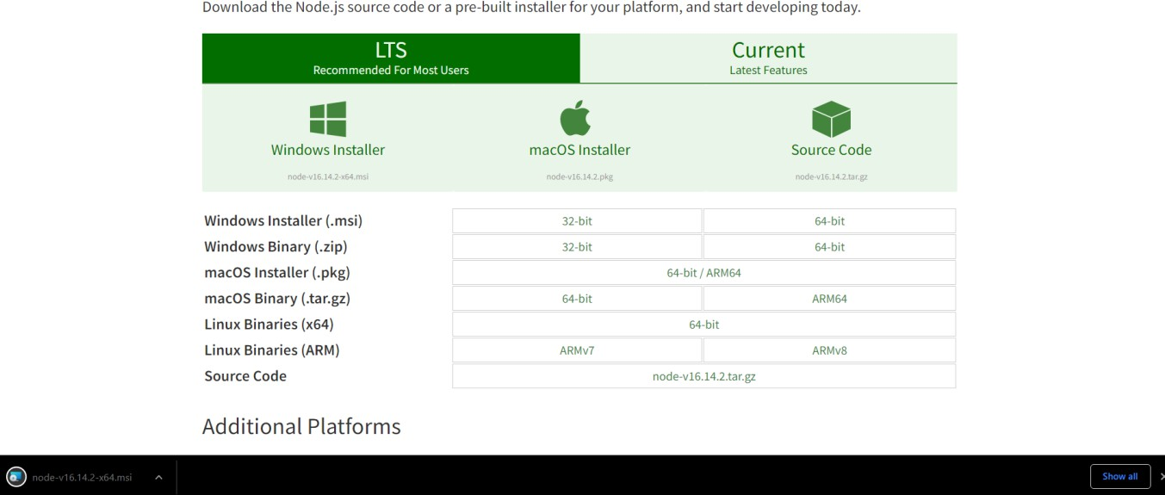
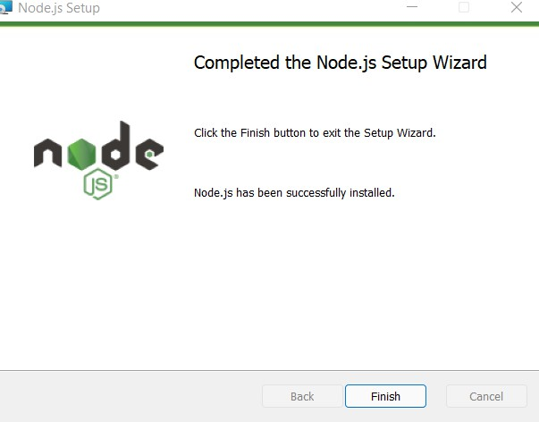
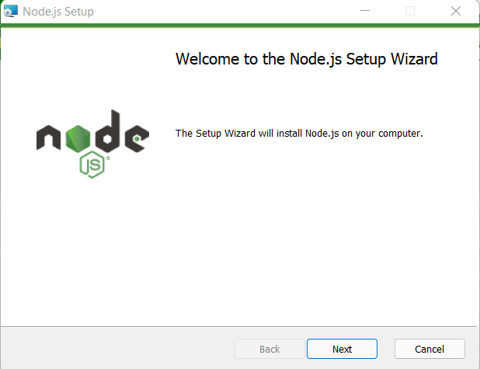
- Install Node JS

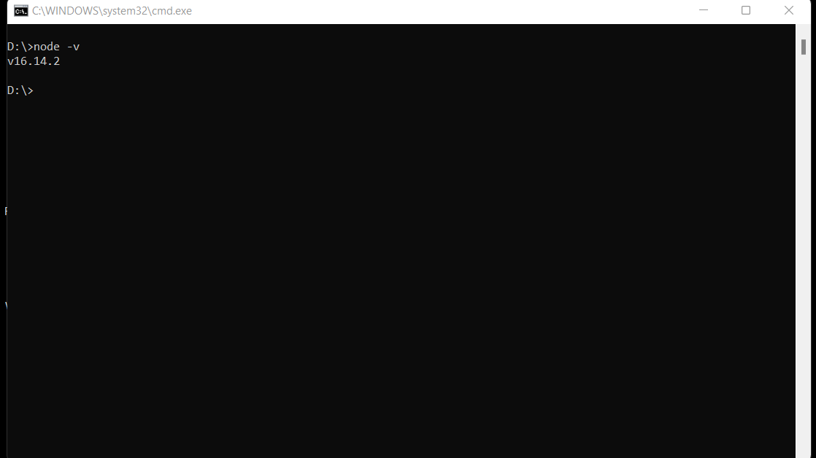
- Verify Node JS Installation
1B.
Aim : Node JS REPL Terminal
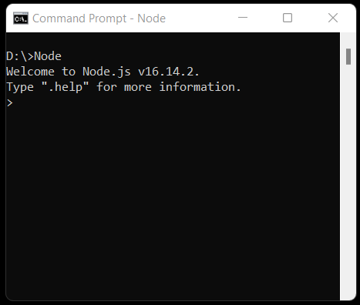
- Type Node in CMD and press enter

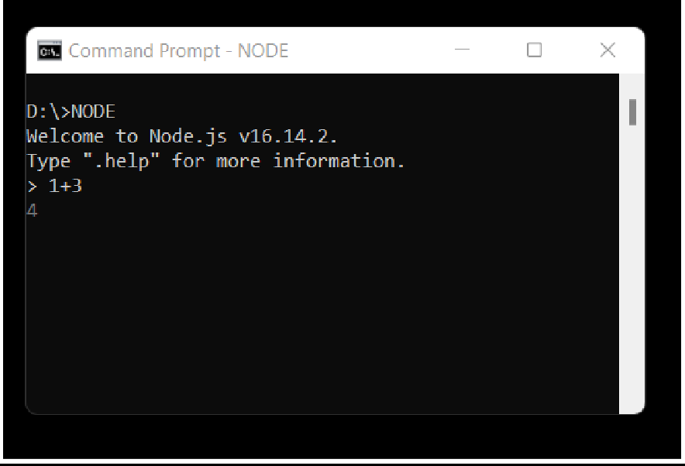
- Enter expression i.e., 1+3 and press enter

Practical 2 : Node.js Modules, Events & Functions
2A.
Aim : Node JS callback pattern function callback
Code :
Main.js
var fs = require("fs");
var data = fs.readFileSync('input.txt');
console.log(data.toString());
console.log("Program Ended");

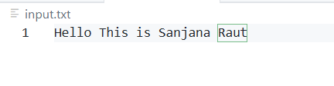

Output :
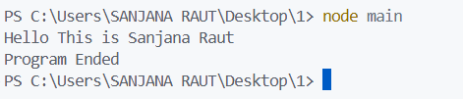

2B.
AIM : Node JS callback pattern function callback
CODE :
var EventEmitter = require('events');
const myEmitter = new EventEmitter();
function c1() {
console.log('an event occurred!');
}
function c2() {
console.log('yet another event occurred!');
}
myEmitter.on('eventOne', c1);
// Register for eventOne
myEmitter.on('eventOne', c2);
// Register for eventOne
myEmitter.emit('eventOne');
OUTPUT

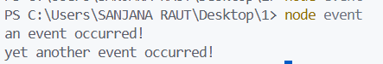

Practical 3 : File Handling & HTTP Web Server

3A.
AIM : FS Module File Path
CODE :
// Require the fs module
var fs = require('fs');

// Check if it is a file
var statsFile = fs.statSync("C:/Users/SANJANA RAUT/Desktop/1/file.js");
console.log('is file ? ' + statsFile.isFile());

// Check if it is a directory
var statsDir = fs.statSync("C:/Users/SANJANA RAUT/Desktop/1");
console.log('is directory ? ' + statsDir.isDirectory());
OUTPUT :
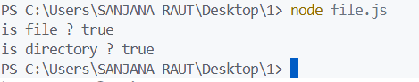

3B.
AIM : Read File in Node Js
CODE :
// Require the fs module
var fs = require("fs");
fs.readFile("input.txt", function(err, buf) {
console.log(buf.toString());
});

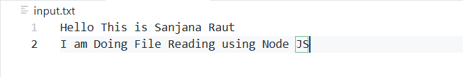
OUTPUT :

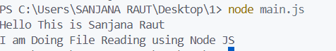

Practical 4 : Databases

4A.
AIM : Connect MySQL with Node.JS

- Add a folder with name node-mysql
- In Command Prompt navigate to folder node-mysql folder and enter npm init command and press enter (for adding package.json file)

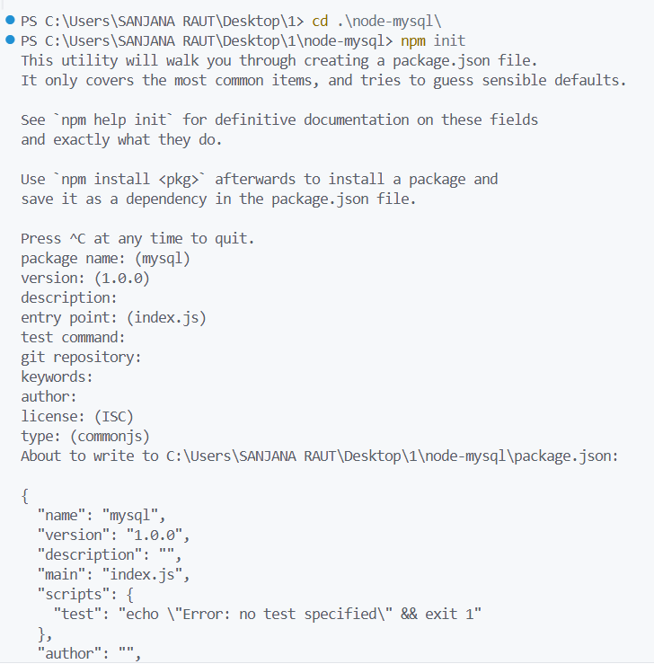

- Enter Command npm install mysql and press enter (for installing mySql Package)

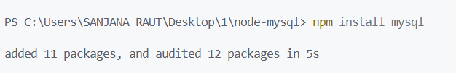

- Create Database todoapp in MySql

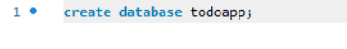

- Create a file name Connect.js and add below code in it

Code :
let mysql = require('mysql');
let connection = mysql.createConnection({ host: 'localhost',
user: 'root', password: 'sanju', database: 'todoapp'
});

connection.connect(function(err) { if (err) {
return console.error('error: ' + err.message);
}
console.log('Connected to the MySQL server.');
});
- Open command prompt Navigate to folder where connect.js is located And run command node connect.js and press enter

4B.
AIM : Insert Data in SQL using Node.JS
CODE :
Config.js
let config = {
host:'localhost',
user:'root',
password:'sanju',
database:'todoapp'
};
module.exports = config;
Insert.js
let mysql = require('mysql');
let config = require('./config.js');
let connection = mysql.createConnection(config);
// Connect to database
connection.connect(function(err) {
if (err) throw err;
console.log("Connected!");
});
// Insert statement
let sql = "INSERT INTO todos(title, completed) VALUES('Learn how to insert a new row', true)";

// Execute query
connection.query(sql, function(err, result) {
if (err) throw err;
console.log("1 record inserted");
});
// Close connection
connection.end();

OUTPUT
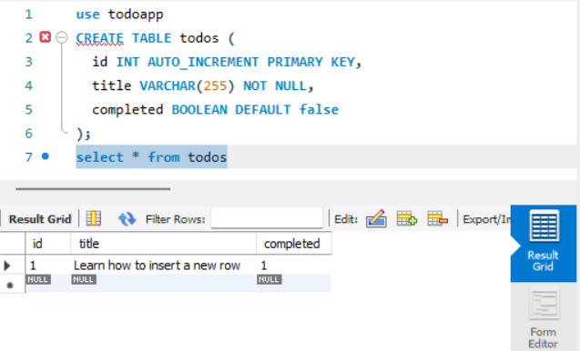

Practical 5 : Angular JS Basics
5A.
AIM : Setting Up the Environment
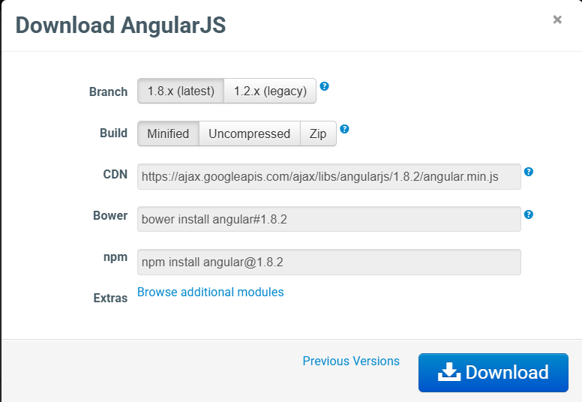

- Click on Download
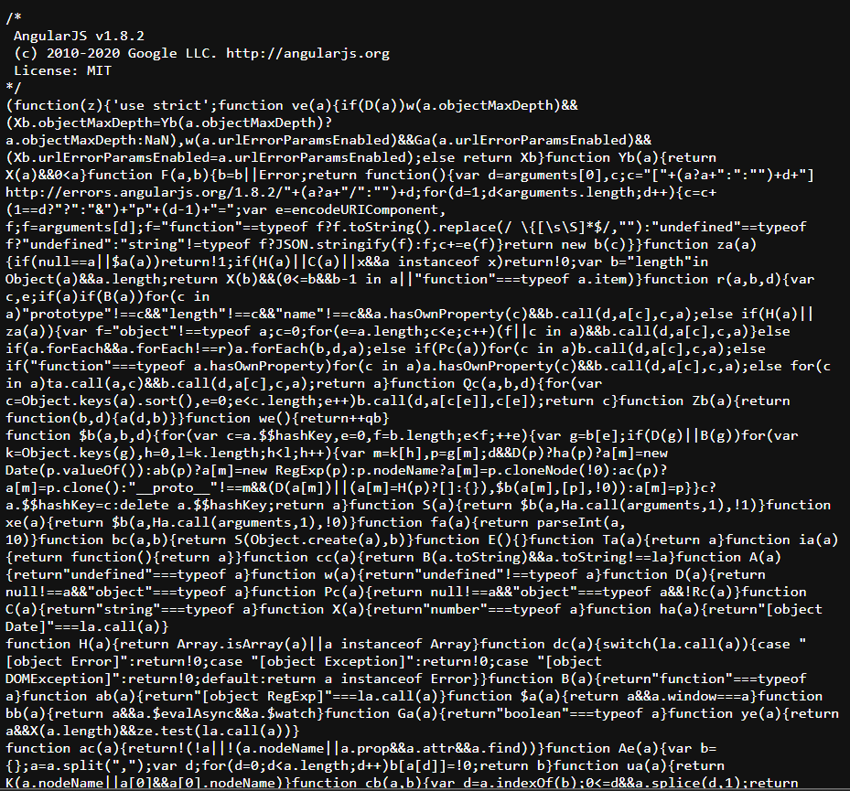
- Copy this and make a new file angular.js and paste the code

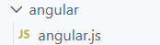

5B.
AIM : First Application (Multiplier)
CODE :
<!DOCTYPE html>
<html>
<head>
<title>First AngularJS Application</title>
<script src="angular.js"></script>
</head>
<body ng-app>
<h1>First AngularJS Application</h1>

Enter Numbers to Multiply:
<input type="text" ng-model="Num1" /> x <input type="text" ng-model="Num2" />
= <span>{{Num1 * Num2}}</span>
</body>
</html>
OUTPUT :
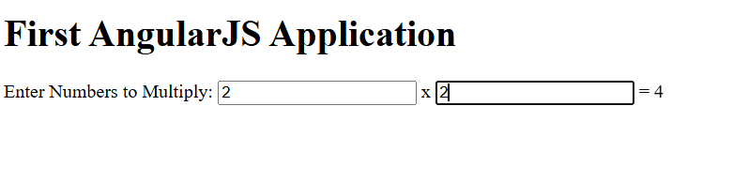

Practical 6 : Filters, Directive
6A.
AIM : Experiment: program to display your name with welcome note: HELLO
CODE :
<html>
<head>
<title>AngularJS First Application</title>
</head>
<body>
<h1>Sample Application</h1>
<div ng-app="">
<p>Enter your Name: <input type="text" ng-model="name"></p>
<p>Hello <span ng-bind="name"></span>!</p>
</div>
<script src="https://ajax.googleapis.com/ajax/libs/angularjs/1.8.2/angular.min.js">
</script>

</body>
</html>
OUTPUT :
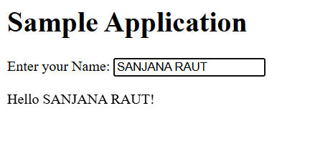

6B.
AIM : Experiment: Create an application using Filters
CODE :
<html>
<head>
<title>Angular JS Filters</title>
<script src="https://ajax.googleapis.com/ajax/libs/angularjs/1.3.14/angular.min.js"></script>
<script>
var mainApp = angular.module("mainApp", []); mainApp.controller('studentController', function ($scope) {
$scope.student = { firstName: "Mahesh", lastName: "Parashar", fees: 500,
subjects: [
{ name: 'Physics', marks: 70 },
{ name: 'Chemistry', marks: 80 },
{ name: 'Math', marks: 65 }
],
fullName: function () { var studentObject;
studentObject = $scope.student;
return studentObject.firstName + " " + studentObject.lastName;
}};
});
</script>
</head>
<body>
<h2>AngularJS Sample Application</h2>
<div ng-app="mainApp" ng-controller="studentController">
<table border="0">
<tr>
<td>Enter first name:</td>
<td><input type="text" ng-model="student.firstName"></td>
</tr>
<tr>
<td>Enter last name: </td>
<td><input type="text" ng-model="student.lastName"></td>
</tr>
<tr>
<td>Enter fees: </td>
<td><input type="text" ng-model="student.fees"></td>
</tr>
<tr>
<td>Enter subject: </td>
<td><input type="text" ng-model="subjectName"></td>
</tr>
</table>
<br />
<table border="0">
<tr>
<td>Name in Upper Case: </td>
<td>{{student.fullName() | uppercase}}</td>
</tr>
<tr>
<td>Name in Lower Case: </td>
<td>{{student.fullName() | lowercase}}</td>
</tr>
<tr>
<td>fees: </td>
<td>
{{student.fees | currency}}
</td>
</tr>
<tr>
<td>Subject:</td>
<td>
<ul>
<li ng-repeat="subject in student.subjects |
filter: subjectName |orderBy:'marks'">
{{ subject.name + ', marks:' + subject.marks }}
</li>
</ul>
</td>
</tr>
</table>
</div>
</body>
</html>
OUTPUT :
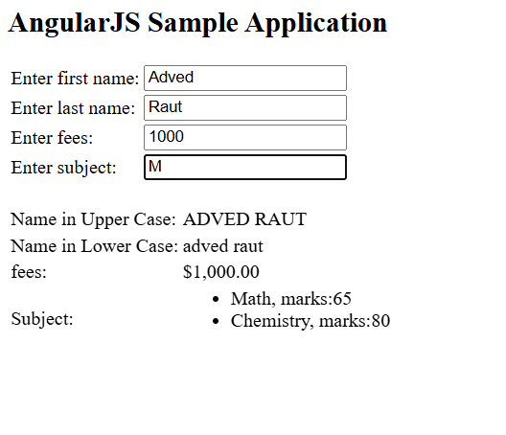

Practical 7 : Controllers
7A.
AIM : Programming Controllers & $scope object
CODE :
<!DOCTYPE html>
<html>
<head>
<title>AngualrJS Controller</title>
<script src="angular.js"></script>
<script>
var ngApp = angular.module('myNgApp', []);
ngApp.controller('myController', function ($scope) {
$scope.message = "Angular Controller Program !";
});
</script>
</head>
<body ng-app="myNgApp">
<div ng-controller="myController">
{{message}}
</div>
</body>
</html>
OUTPUT :

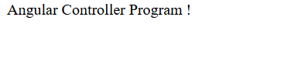

7B.
AIM : Adding Behavior to a Scope Object
CODE :
<!DOCTYPE html>
<html><head>
<title>AngualrJS Controller</title>
<script src="angular.js"></script>
<script>
var ngApp = angular.module('myNgApp', []);
ngApp.controller('myController', function ($scope) {
$scope.message = "This is myController";
});
ngApp.controller('anotherController', function ($scope) {
$scope.message = "This is anotherController";
});
</script></head>
<body ng-app="myNgApp">
<div id="div1" ng-controller="myController"> Message: {{message}} <br />
<div id="div2">
Message: {{message}}
</div></div>
<div id="div3">
Message: {{message}}
</div>
<div id="div4" ng-controller="anotherController"> Message: {{message}}
</div></body></html>
OUTPUT :
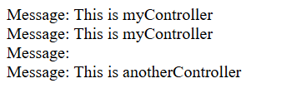
Practical 8 :
8A.
AIM : Create Simple Angular Forms using different input controls & events
CODE :
<!DOCTYPE html>
<html>
<head>
<title>Angular JS Forms</title>
<script src="angular.js"></script>
<script>
var mainApp = angular.module("mainApp", []);
mainApp.controller('studentController', function ($scope) {
$scope.reset = function () {
$scope.firstName = "idol";
$scope.lastName = "mumbai university";
$scope.email = "mca@mu.ac.in";
};
$scope.submit = function () {
alert("Form submitted successfully!");
};
$scope.reset();
});
</script>
<style>
table, th, td {
border: 1px solid grey;
border-collapse: collapse;
padding: 5px;
}
table tr:nth-child(odd) { background-color: lightpink; }
table tr:nth-child(even) { background-color: lightyellow; }
</style>
</head>
<body>
<h2>AngularJS Sample Application</h2>
<div ng-app="mainApp" ng-controller="studentController">
<form name="studentForm" novalidate>
<table>
<tr>
<td>Enter first name:</td>
<td>
<input name="firstname" type="text" ng-model="firstName" required>
<span style="color:red" ng-show="studentForm.firstname.$dirty && studentForm.firstname.$invalid">
<span ng-show="studentForm.firstname.$error.required">First Name is required.</span>
</span> </td></tr>
<tr>
<td>Enter last name:</td>
<td>
<input name="lastname" type="text" ng-model="lastName" required>
<span style="color:red" ng-show="studentForm.lastname.$dirty && studentForm.lastname.$invalid">
<span ng-show="studentForm.lastname.$error.required">Last Name is required.</span>
</span></td></tr>
<tr>
<td>Email:</td>
<td>
<input name="email" type="email" ng-model="email" required>
<span style="color:red" ng-show="studentForm.email.$dirty && studentForm.email.$invalid">
<span ng-show="studentForm.email.$error.required">Email is required.</span>
<span ng-show="studentForm.email.$error.email">Invalid email address.</span>
</span>
</td></tr>
<tr>
<td><button type="button" ng-click="reset()">Reset</button></td>
<td>
<button type="button"
ng-disabled="studentForm.firstname.$dirty && studentForm.firstname.$invalid ||
studentForm.lastname.$dirty && studentForm.lastname.$invalid ||
studentForm.email.$dirty && studentForm.email.$invalid"
ng-click="submit()">
Submit
</button>
</td>
</tr>
</table>
</form>
</div>
</body>
</html>
OUTPUT :
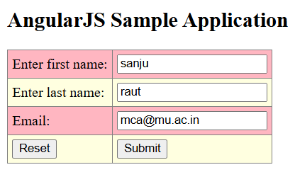

8B.
AIM : Implement the concept of Single page application .
CODE :
Spa.html
<!doctype html>
<html ng-app="myApp">
<head>
<script src="https://cdnjs.cloudflare.com/ajax/libs/angular.js/1.4.7/angular.min.js"></script>
<script src="https://cdnjs.cloudflare.com/ajax/libs/angular.js/1.4.7/angular-route.min.js"></script>
</head>
<body>
<script type="text/ng-template" id="pages/first.html">
<h1>First</h1>
<h3>{{message}}</h3>
</script>
<script type="text/ng-template" id="pages/second.html">
<h1>Second</h1>
<h3>{{message}}</h3>
</script>
<script type="text/ng-template" id="pages/third.html">
<h1>Third</h1>
<h3>{{message}}</h3>
</script>
<a href="#/">First</a>
<a href="#/second">Second</a>
<a href="#/third">Third</a>
<div ng-view></div>
<script src="app.js"></script>
</body>
</html>
App.js
var app = angular.module("myApp", ['ngRoute']);
app.config(function($routeProvider) {
$routeProvider
.when("/", {
templateUrl: "pages/first.html",
controller: "FirstController"
})

.when("/second", {
templateUrl: "pages/second.html",
controller: "SecondController"
})

.when("/third", {
templateUrl: "pages/third.html",
controller: "ThirdController"
})
.otherwise({
redirectTo: "/"
});
});

app.controller("FirstController", function($scope) {
$scope.message = "This is the first page";
});

app.controller("SecondController", function($scope) {
$scope.message = "This is the second page";
});

app.controller("ThirdController", function($scope) {
$scope.message = "This is the third page";
});
OUTPUT :

